


Bolton Muslim Welfare Trust
Al Nur Supplementary School

APPLICATION FOR LEAVE OF ABSENCE FOR YOUR CHILD DURING TERM-TIME

As a Parent/Carer, you should complete this form and return it to school AT LEAST FOUR (4) WEEKS before the date when you want the period of absence to start.

(A separate application must be completed for each child)

Child’s Full Name: ………………......................…….........................................................….

Date of Birth…………….........................Year Group……………Class/Form…….………….

Address………………………………………………………..................…………………………

Period of Absence: From………………...........……. To……………...................…. (inclusive)

Reason for Requesting Absence (if request is for a family holiday, please give exceptional circumstances on why it MUST be in term time)

Name:…………………………………………… Relationship to child:.........................................

Signed:………………………………………………. Date:…………………………

The Madrasah will consider these points before authorising leave:

- Your child’s previous attendance history

- Your child’s stage of education and ability to catch up on missed studies

- The time of year (beginning of term and assessment periods)

- The nature of the request (e.g. exceptional circumstances)


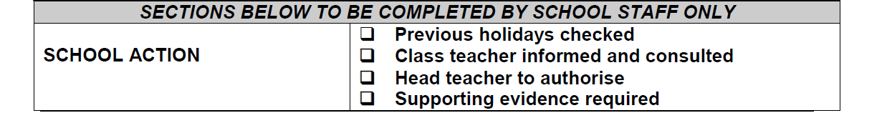
SECTIONS BELOW TO BE COMPLETED BY SCHOOL STAFF ONLY

 Previous holidays checked
 Class teacher informed and consulted
 Head teacher to authorise  Supporting evidence required
SCHOOL ACTION

